VAULT READER 3

Racial Spectacle, National Ritual, and Conditional Belonging
Bruno Mars, Bad Bunny, and the Politics of America’s Super Bowl Halftime Show

Six-Week Facilitated Workshop Series

Suggested Citation
Center for Sight and Sound. (2026). Racial spectacle, national ritual, and conditional belonging: Bruno Mars, Bad Bunny, and the politics of America’s Super Bowl halftime show (CSS Vault Reader). Center for Sight and Sound.

Target Context
- Mixed cohorts of domestic and international students
- Facilitator-led curricular or co-curricular environments
- Six complementary but discrete modular sessions
- Institutional training, classroom deployment, or workshop use

About This Reader
This Vault Reader provides a complete six-module curriculum for analyzing racial spectacle through two major Super Bowl halftime performances. It trains participants to analyze media spectacle as institutional authorization and ideological instruction rather than entertainment alone.

Participants learn to identify how spectacle constructs belonging, legitimacy, and hierarchy, and develop representational literacy necessary for critical engagement with media.

How to Use This Reader
Each module may be deployed independently or as part of a complete curriculum. Facilitators should guide participants through still frame capture, frame analysis exercises, and structured assignments. RLIOA assessment may be integrated to measure learning outcomes [Addendum 1].

Copyright and Use
© 2026, Center for Sight and Sound. All Rights Reserved.
This reader may be used for educational and training purposes within affiliated programs. Redistribution, commercial use, or derivative publication requires written permission from the Center.

Introduction: The Super Bowl as Global Racial Spectacle
The Super Bowl halftime show operates as ideological spectacle. It authorizes identities and encodes national belonging through televisual representation.

This reader establishes CSS methodological standards integrating frame analysis, mythological reading, institutional critique, and global reception analysis.

CSS Televisual Frame Analysis Method
Frame position, spatial hierarchy, and visual context encode meaning. CSS frame analysis examines authority, legitimacy, and belonging through visual grammar.

Case Study I: Bruno Mars Frame Analysis

Figure 1. Opening stadium authority frame
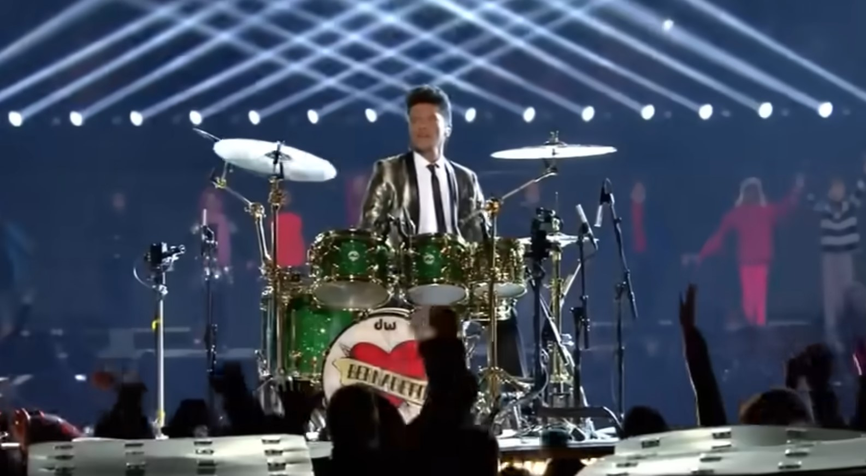
Mars enters institutional space already authorized.

Figure 2. Center-frame performer close shot
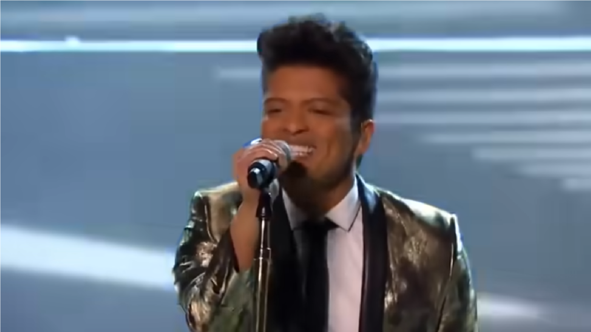
Ambiguity enhances cross-racial accessibility.

Figure 3. Audience affirmation frame
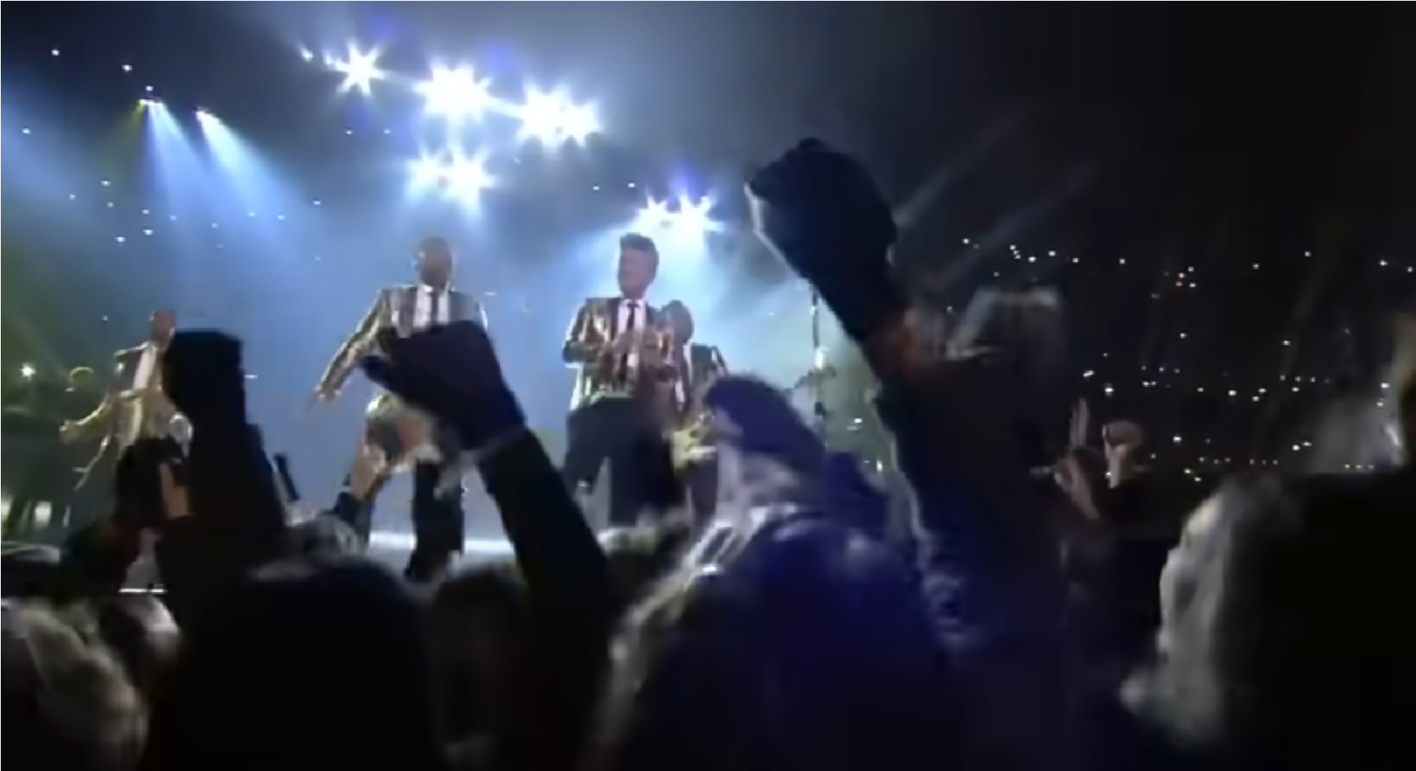
Audience reaction reinforces institutional legitimacy.

Assimilative Authorization
Bruno Mars’ Super Bowl performance was framed through universal pop iconography.
His Puerto Rican and Filipino identity was not foregrounded, enabling racial ambiguity. The camera emphasized familiarity, nostalgia, and universal appeal. This framing enabled assimilation. Mars was authorized not through ethnic specificity, but through cross-racial palatability. His performance encoded a myth of post-racial inclusion, where difference is permitted so long as it remains culturally contained.

Case Study II: Bad Bunny Frame Analysis

Figure 4. Puerto Rican environmental staging
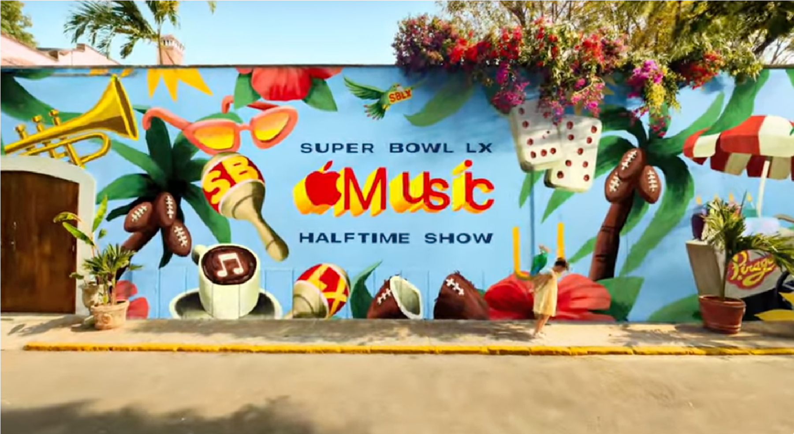
Cultural specificity establishes spatial identity.

Figure 5. Center-frame performer with cultural markers
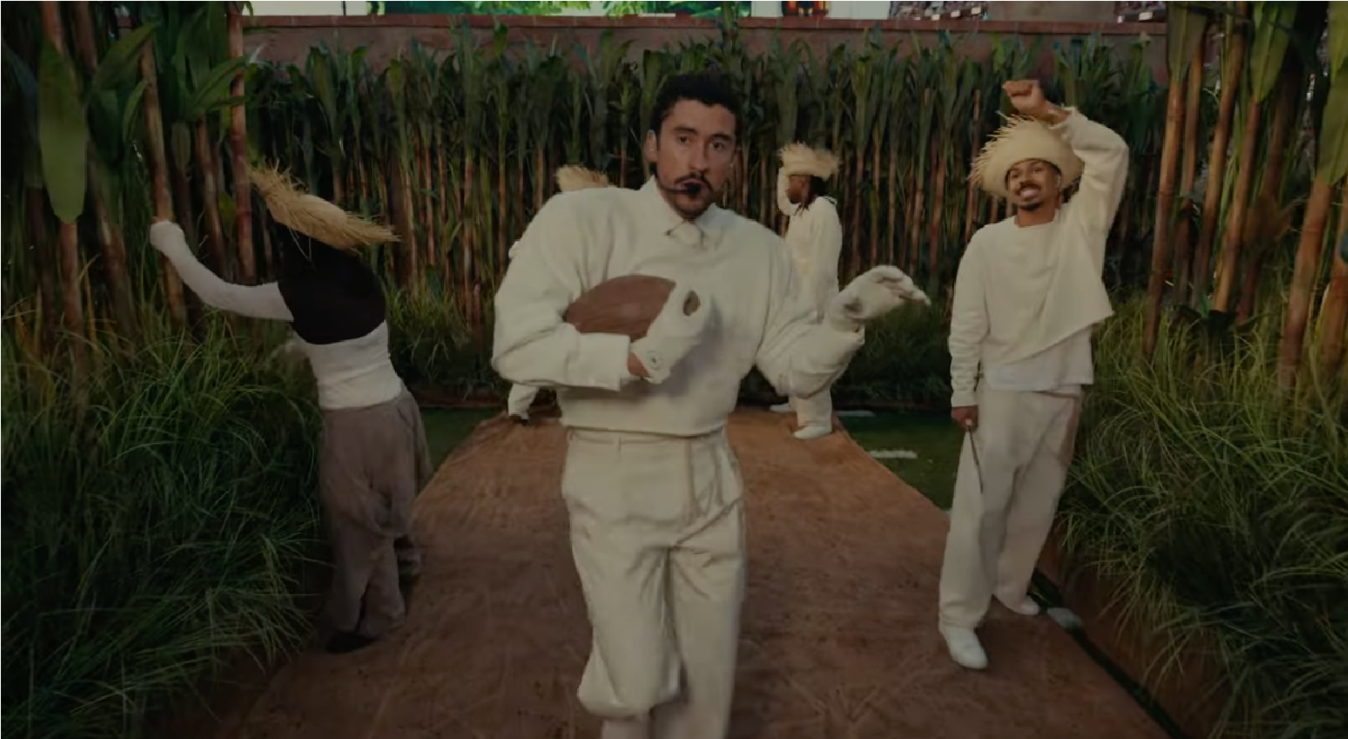
Negotiated inclusion through visible cultural identity.

Figure 6. Wide spectacle containment frame
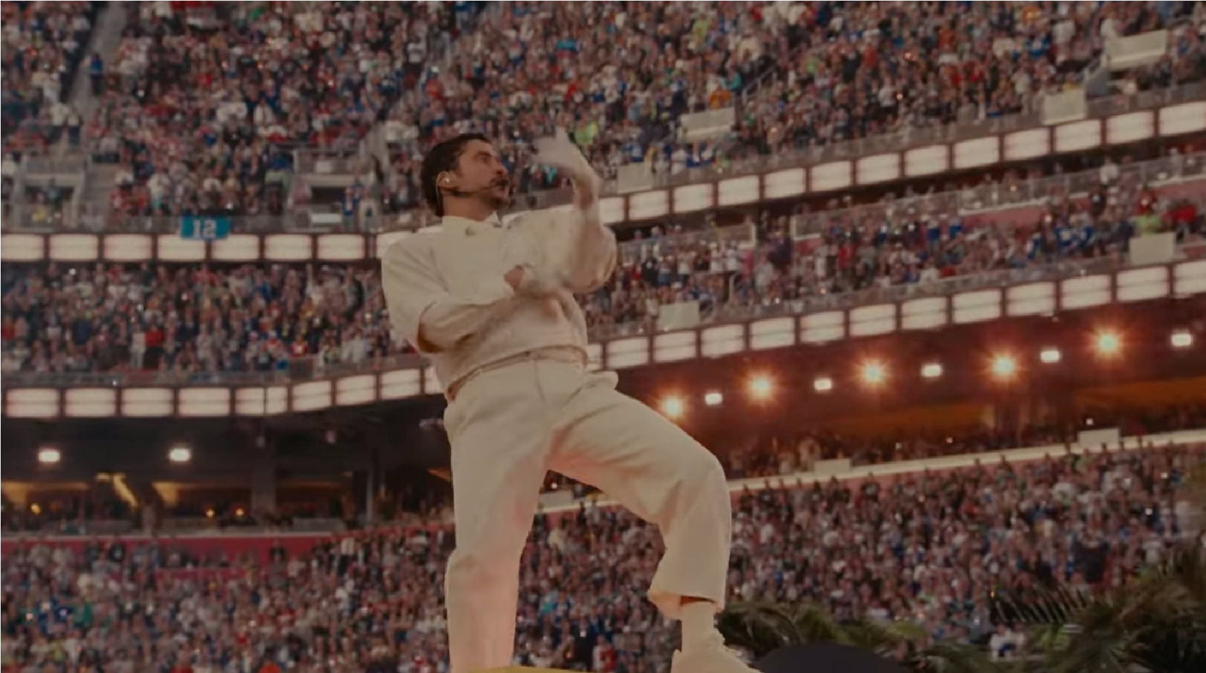
Institutional containment remains visible.

Negotiated Cultural Specificity
Bad Bunny’s halftime show centered Puerto Rican visual culture. Spanish language, architecture, and cultural imagery were foregrounded. Unlike Mars, his ethnic identity was not muted.

This spectacle negotiated belonging explicitly. It asserted cultural specificity while remaining contained within institutional authorization. The performance reflected Puerto Rico’s ambiguous political relationship to the United States, encoding both belonging and distance simultaneously.

Mythological and Institutional Analysis
Mars encodes assimilation myth. Bad Bunny encodes negotiated belonging myth.

Global Reception and Political Economy
Spectacle expands markets while encoding hierarchy. Ethnic ambiguity appeals across state and race.

Campus and Representational Literacy Implications Spectacle shapes perception prior to lived interaction.

Still Frame Capture Protocol for CSS Spectacle Analysis

Purpose:
Still frame analysis allows participants to examine how spectacle constructs meaning visually. Televisual images are structured compositions that encode authority, legitimacy, and belonging.

Procedure:
- Play halftime performance video.
- Pause at designated timestamps.
- Capture screenshot.
- Analyze frame using CSS frame analysis questions.

Example Bruno Mars timestamps:
- Opening stadium authority shot
- First center-frame performer positioning
- Audience affirmation shot

Example Bad Bunny timestamps:
- Puerto Rico environmental staging
- Center frame performer identity shot
- Wide shot revealing cultural containment

Analysis Questions:
- Who occupies center frame?
- What institutional symbols are present?
- What cultural markers are emphasized or muted?
- How does this frame construct legitimacy?

CURRICULUM

Module 1: Foundations of Racial Spectacle

Learning Objectives
- Define racial spectacle
- Identify institutional control
- Understand ideological function

Key Concepts
- Spectacle
- Institutional authority
- Representation

Media Examples
- View halftime performance opening shots

Discussion Prompts
- How does spectacle construct legitimacy?

Assignment Option
Frame identification exercise

Purpose:
Train participants to recognize spectacle as institutional structure.

Procedure:
Participants capture three still frames from any halftime performance and analyze institutional positioning, performer placement, and authority signals.

Expected Outcome:
Participants develop foundational representational literacy and ability to identify spectacle as constructed visual grammar.

Module 2: The Super Bowl as National Ritual and Institutional Authorization

Learning Objectives
- Understand national authorization
- Analyze institutional stage

Key Concepts
- National ritual
- Institutional power

Media Examples
- View Bruno Mars entrance

Discussion Prompts
- How does institutional space authorize identity?

Assignment Option
Institutional mapping exercise

Purpose:
Reveal institutional actors involved in spectacle production.

Procedure:
Participants map institutional relationships between NFL, broadcasters, sponsors, and performers.

Expected Outcome:
Participants understand spectacle as institutional product rather than individual expression.

Module 3: Bruno Mars Frame Analysis

Learning Objectives
- Analyze assimilation
- Understand ambiguity

Key Concepts
- Assimilation
- Ambiguity

Media Examples
- Analyze Mars center frame shot

Discussion Prompts
- How does ambiguity enable inclusion?

Assignment Option
Frame-by-frame visual analysis

Purpose:
Analyze assimilation and racial ambiguity in spectacle.

Procedure:
Participants analyze three still frames and evaluate how ambiguity enables institutional inclusion.

Expected Outcome:
Participants recognize assimilation as representational mechanism.

Module 4: Bad Bunny Frame Analysis

Learning Objectives
- Analyze specificity
- Understand language politics

Key Concepts
- Specificity
- Language politics

Media Examples
- Analyze Bad Bunny Puerto Rico staging

Discussion Prompts
- How does cultural specificity function?

Assignment Option
Comparative visual critique

Purpose:
Examine cultural specificity and negotiated belonging.

Procedure:
Participants compare still frames with Bruno Mars performance and analyze cultural staging.

Expected Outcome:
Participants identify negotiated inclusion and institutional containment.

Module 5: Comparative Spectacle Analysis

Learning Objectives
- Compare both performances
- Analyze containment

Key Concepts
- Comparative representation
- Containment

Media Examples
- Compare staging

Discussion Prompts
- What differs structurally?

Assignment Option
Comparative analysis assignment

Purpose:
Compare representational strategies across performances.

Procedure:
Participants produce written or visual comparative analysis examining assimilation versus specificity.

Expected Outcome:
Participants develop advanced comparative representational literacy.

Module 6: Counter-Spectacle Multimedia Critique

Learning Objectives
- Develop critique
- Create counter-spectacle

Key Concepts
- Critique
- Counter-spectacle

Media Examples
- Create media critique

Discussion Prompts
- How can spectacle be challenged?

Assignment Option
Multimedia critique project

Purpose:
Transform representational literacy into institutional critique.

Procedure:
Participants create multimedia critique analyzing spectacle structure.

Expected Outcome:
Participants demonstrate mastery of spectacle analysis and institutional critique.

Facilitator Training Section

Managing Representational Analysis:
Redirect participants from personal preference toward structural analysis. Focus discussion on institutional framing rather than individual taste.

Guiding Frame Critique:
Encourage participants to analyze frame composition, institutional symbols, and performer positioning.

Centering Institutional Analysis:
Help participants identify institutional structures that produce spectacle.

Maintain CSS Pedagogical Approach:
Facilitators should maintain analytical neutrality while encouraging structural critique.

Assessment Integration (RLIOA)

RLIOA assessment may be administered before and after curriculum deployment to measure representational literacy development and perception change [Addendum 1].

ADDENDUM 1

Representational Literacy and Interaction Outcomes Assessment (RLIOA)

Adapted for: Racial Spectacle, National Ritual, and Conditional Belonging Vault Reader

Purpose of RLIOA
The RLIOA measures growth in representational literacy, interpretive flexibility, and institutional analysis capacity. It should be administered before and after curriculum deployment. Compare scores to measure growth in representational literacy and interpretive flexibility.

Domain 1: Representational Literacy
I recognize that media representations are constructed rather than natural. (1 = Strongly
Disagree … 5 = Strongly Agree)

I understand that spectacle reflects institutional power. (1 = Strongly Disagree … 5 =
Strongly Agree)

I can identify visual techniques used to construct legitimacy. (1 = Strongly Disagree … 5 = Strongly Agree)

Domain 2: Institutional Awareness
I understand that media spectacle reflects institutional interests. (1 = Strongly Disagree … 5 = Strongly Agree)

I recognize institutional authorization in media representation. (1 = Strongly Disagree
… 5 = Strongly Agree)

I understand that representation reflects power relationships. (1 = Strongly Disagree … 5 = Strongly Agree)

Domain 3: Interpretive Flexibility
I am able to analyze media representation critically. (1 = Strongly Disagree … 5 = Strongly Agree)

I recognize multiple possible interpretations of media spectacle. (1 = Strongly Disagree … 5 = Strongly Agree)

I question media portrayals of identity. (1 = Strongly Disagree … 5 = Strongly Agree)

Domain 4: Spectacle Analysis Confidence
I feel confident analyzing media spectacle. (1 = Strongly Disagree … 5 = Strongly Agree)

I can identify how spectacle constructs belonging. (1 = Strongly Disagree … 5 =
Strongly Agree)

I can critique institutional representation. (1 = Strongly Disagree … 5 = Strongly Agree)

ADDENDUM 2

Suggested Reading

The following readings provide theoretical, historical, and institutional grounding for the analysis of racial spectacle, media representation, institutional authorization, and critical production training explored in this Vault Reader. These works are organized to support facilitator preparation, student inquiry, and institutional deployment.

I. Foundational Theory: Representation, Meaning, and Identity
These texts establish the conceptual foundations for understanding representation as a cultural, semiotic, and social system through which meaning is produced and circulated.

Barthes, R. (1972). Mythologies (A. Lavers, Trans.). Hill and Wang. (Original work published 1957)

Goffman, E. (1959). The presentation of self in everyday life. Anchor Books.

Hall, S. (1997). The work of representation. In S. Hall (Ed.), Representation: Cultural representations and signifying practices (pp. 13–74). Sage.

hooks, b. (1992). Black looks: Race and representation. South End Press.

II. Media Spectacle, Institutional Power, and Cultural Authorization
These works examine media as institutional structure, spectacle as ideological process, and representation as an outcome shaped by political economy, cultural authority, and structural power.

Brooks, D. A., & Hébert, L. P. (2006). Gender, race, and media representation. In J. Downing, D. McQuail, P. Schlesinger, & E. Wartella (Eds.), The Sage handbook of media studies (pp. 297–317). Sage.

Couldry, N. (2003). Media rituals: A critical approach. Routledge.

Entman, R. M. (1992). Blacks in the news: Television, modern racism and cultural change. Journalism Quarterly, 69(2), 341–361. https://doi.org/10.1177/107769909206900209

Gray, H. (1995). Watching race: Television and the struggle for Blackness. University of Minnesota Press.

Kellner, D. (2003). Media spectacle. Routledge.

Kellner, D. (2010). Media spectacle and media events: Some critical reflections. In N. Couldry, A. Hepp, & F. Krotz (Eds.), Media events in a global age (pp. 76–91). Routledge.

Lotz, A. D. (2014). The television will be revolutionized (2nd ed.). New York University Press.

Lauzen, M. M. (2018). Boxed in 2017–18: Women on screen and behind the scenes in television. Center for the Study of Women in Television and Film.

Turner, G. (2010). Ordinary people and the media: The demotic turn. Sage.

Whannel, G. (2009). Television and the transformation of sport. The ANNALS of the American Academy of Political and Social Science, 625(1), 205–218.
https://doi.org/10.1177/0002716209339147

III. CSS Core Texts and Curriculum Foundations
These works establish the conceptual, empirical, and pedagogical foundations of the Center for Sight and Sound, including the development of its curriculum, theoretical framework, and institutional mission.

Roth, K. R., & Ritter, Z. S. (2023). A center for sight and sound: Connecting media representations to critical production training. In K. R. Roth et al. (Eds.), Emancipatory change in US higher education. Springer Nature.

Roth, K. R., & Ritter, Z. R. (2016). Channeling race: Media representations and international student perceptions. In J. Prescott (Ed.), Handbook of Research on Race, Gender, and the Fight for Equality. Hershey, PA: IGI Global, Inc.

Roth, K. R. (2015). The other curriculum: Media representations and college going perceptions of African American males (Doctoral dissertation, University of California, Los Angeles).

Ritter, Z., & Roth, K., (2014), Realizing race: Media representations and the uneasy adjustment of international students and African American males on US college campuses. In N. D. Erbe (ed.). Approaches to Managing Organizational Diversity and Innovation. Hershey, PA: IGI Global, Inc.

Ritter, Z. S. (2013). Making and breaking stereotypes: East Asian international students’ experiences with cross-cultural/racial interactions (Doctoral dissertation, University of California, Los Angeles).

